**University of Petroleum and Energy Studies**

School of Computer Science

Department of Cybernetics

**Graphics & Animation Tools**

**LAB FILE**

**(Session: 2020-2021)**

Course: B. Tech with Specialization in Open Source and Open Standards

Submitted To- Submitted By-

Dr. Durgansh Sharma Kunal Ojha

Associate Professor SAP ID -500063333

Department of Cybernetics Roll No. -R100217034

**Experiment 6-** Design of 3D Hut using Blender

Google Drive Link- <https://drive.google.com/drive/folders/1DadihGQM0Y_0o0VrrKi7kSD-JjF8eTfW?usp=sharing>

Step 1- Open blender and select new file type as general

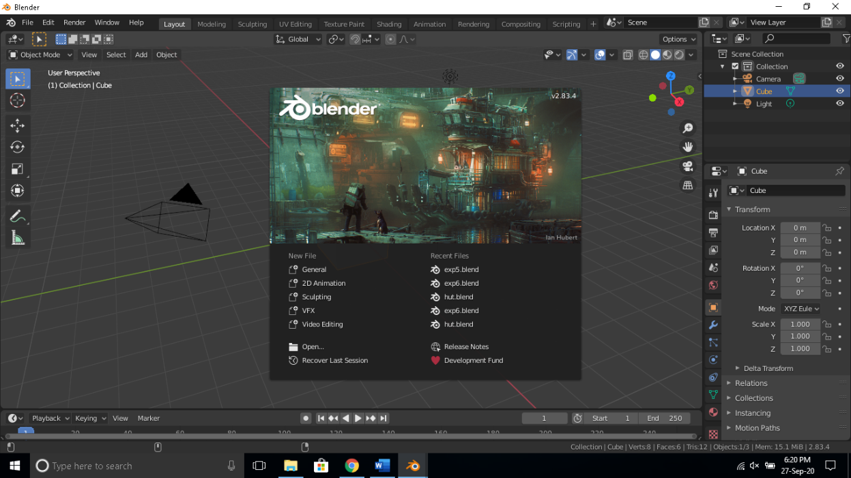

Step 2-In layout mode click on add select mesh and click on cylinder adjust the size of cylinder using scale tool and go to modelling tab and remove the top of the cylinder and also remove a flat curve from the curvature the resulting cylinder should be as shown below.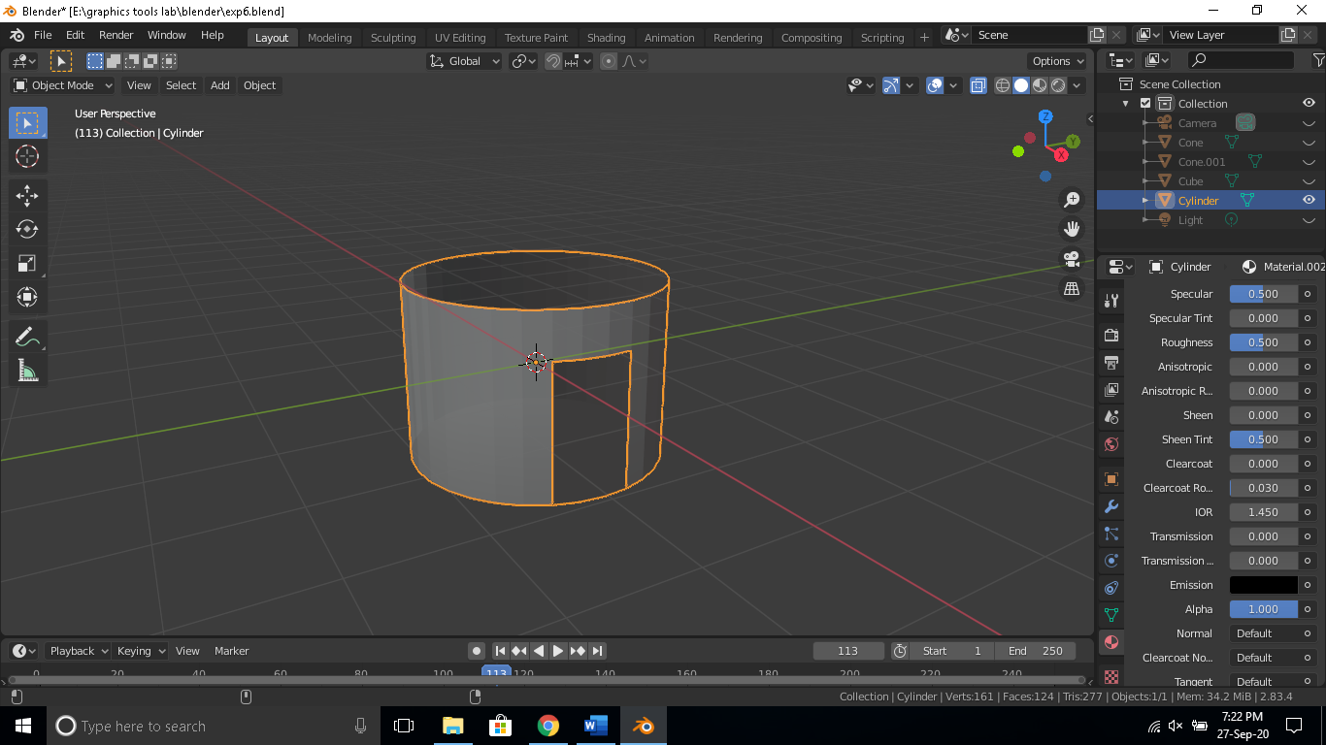

Step 3. Now add a cone and resize it using scale tool remove base of the cone to make it look like top of the hut use to move tool to arrange it shown below.

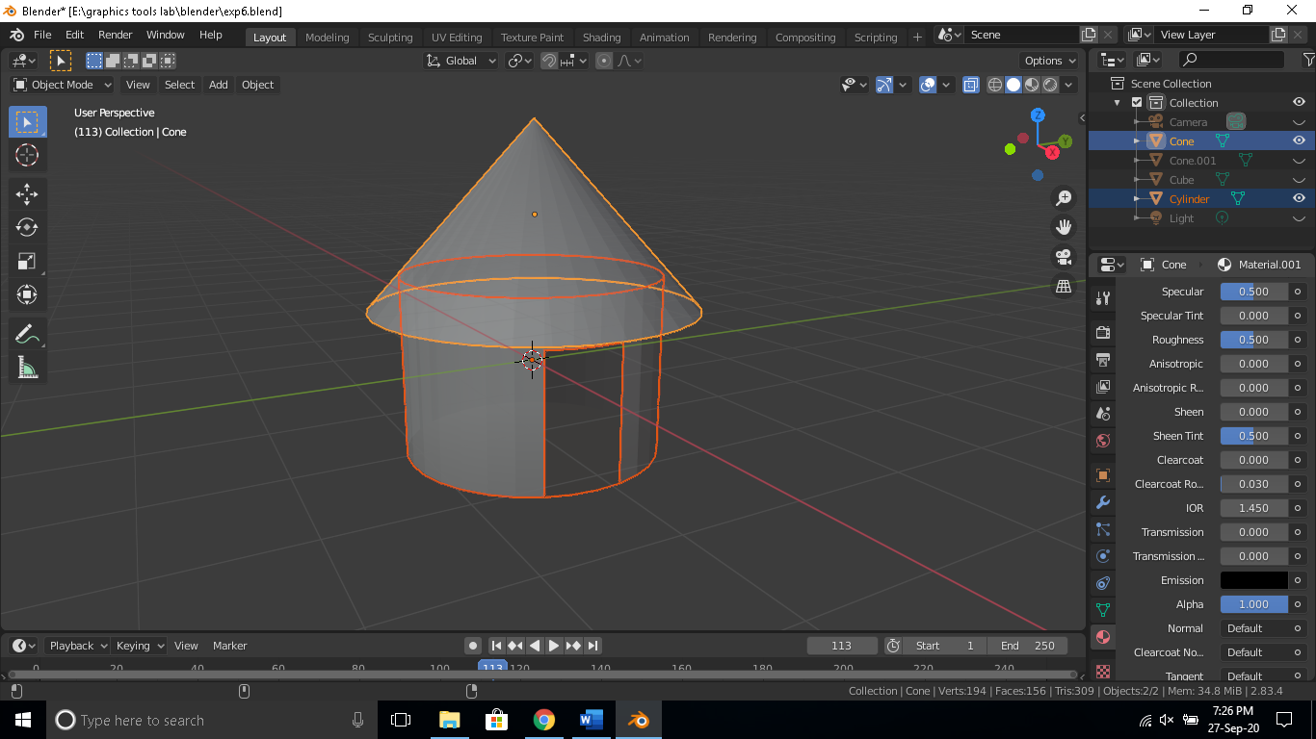

Step 5. Now add a cube and resize it using scale tool to make it of similar size of the hole in the cylinder’s curvature use to move tool to arrange it as shown below.

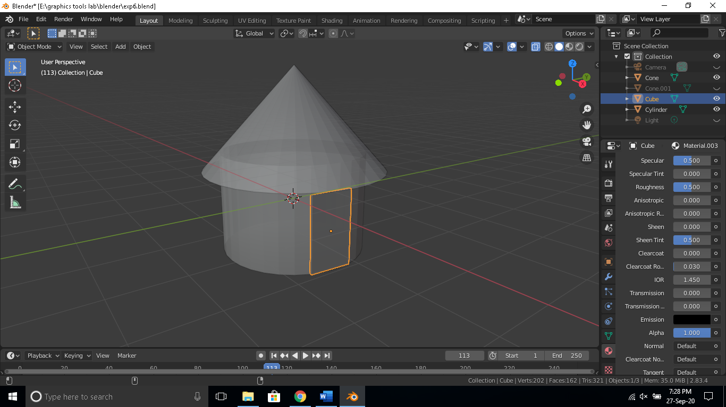

Step 6. Now add a cone and resize it using scale tool remove base of the cone use the rotate tool and move tool to arrange it shown below.

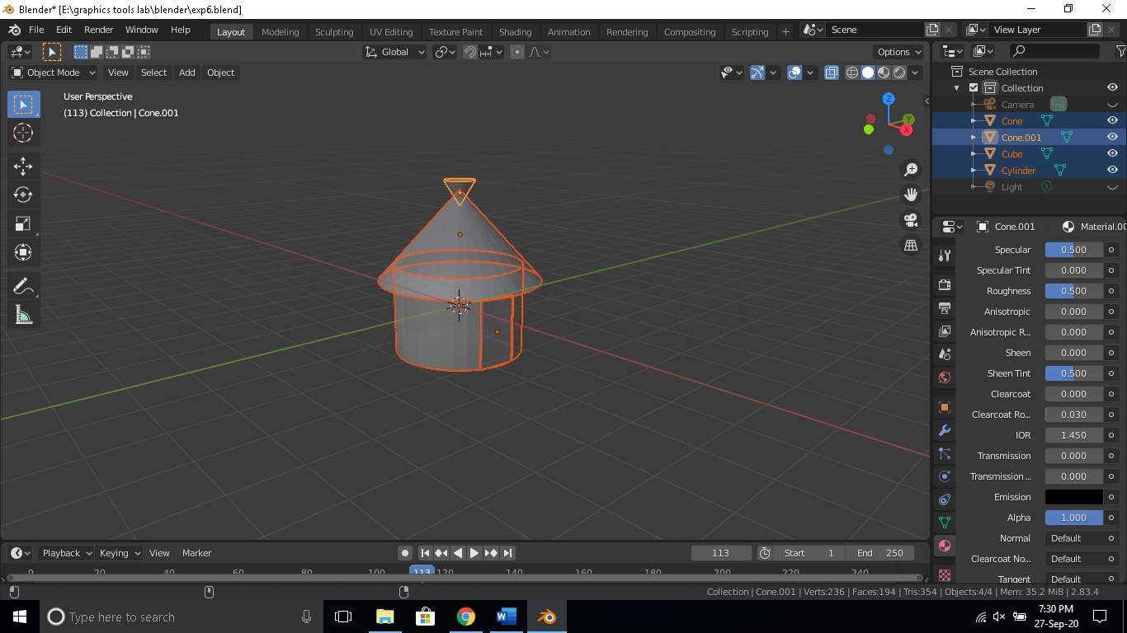

Step 7. Apply color to each surface as suitable and render the output image.

